***Lyddie***

***Chapter 17 – “Doffer”***

Lyddie begged Dr. Morris to let her return to work.  It had been two weeks and she wanted to get back to the looms.  However, Dr. Morris would not let her and Lyddie knew her body was not ready yet.  She could barely walk to the bathroom or to eat dinner.  Lyddie felt angry at her body for [failing](http://bookbuilder.cast.org/view_glossary.php?book=111344&word=86400#curr) her.  She hated being weak and needing other people to help her.



A week later Lyddie really was feeling better and Diana and Brigid came over to visit her.  Brigid brought her some soup and Diana brought her the most amazing present. It was another Charles Dickens book! Lyddie couldn't believe it.

Lyddie asked Diana, "How did you know I liked him??"

Diana said, "Lyddie, anyone who copies a book page by page certainly needs another book by the same author."

Lyddie was very [grateful](http://bookbuilder.cast.org/view_glossary.php?book=111344&word=86401#curr)  for her friends.  Then, she realized she hadn't seen or thought of Mr. Marsden since she had stomped on his foot and gotten sick.  All of a sudden Lyddie was nervous and asked Diana, "Has Mr. Marsden said anything about me?"

Diana said that he hadn't said anything except that he missed her working on the looms because she was one of his best girls.

Lyddie told Diana what had happened when Mr. Marsden tried to kiss her.  Diana was shocked, but said Lyddie shouldn't worry because if anything, Mr. Marsden wouldn't fire Lyddie because he would probably be afraid that Lyddie would tell his wife if he did.

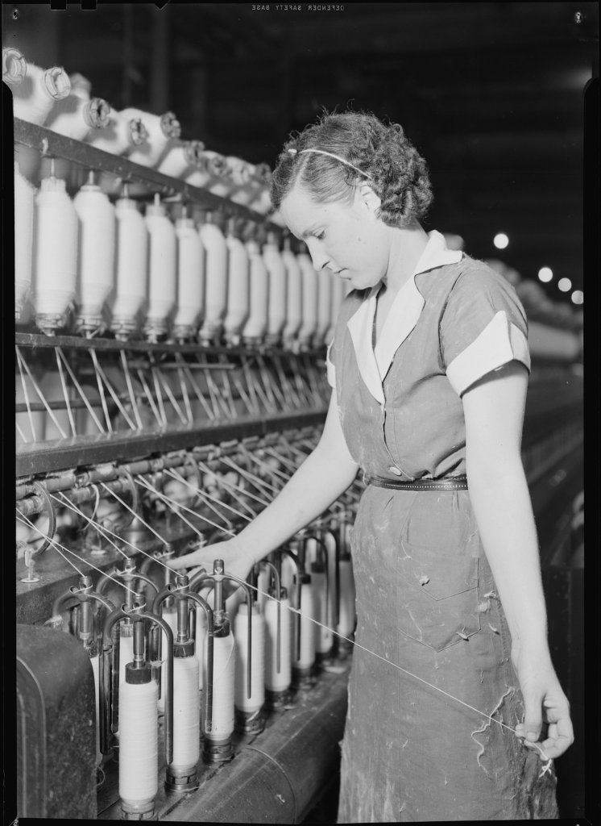

Rachel asked Lyddie if she could get a job as a [doffer](http://bookbuilder.cast.org/view_glossary.php?book=111344&word=86399#curr) in the factory.  Rachel said that Brigid's little sister was the same size and age as her and she was already a doffer.

Lyddie tried to say no to Rachel and tried to convince her that she should go to school instead.  But, Rachel seemed convinced that this was what she wanted to do.



A few days later, Lyddie got a letter.  However, it wasn't from Charlie which is what she had been hoping for.  Instead, it was a letter from Quaker Stevens. It said,

Dear Lyddie,

Your brother asked me to look into the sale of your farm.  All of the questions I have asked so far have no gotten me any answers.  Tomorrow, I will be in your uncle's neighborhood and I will ask him directly then and keep you posted on what he says.  I hope that you and Rachel as well.  My son, Luke Stevens, says hi.

Your friend and neighbor,

Quaker Stevens



Lyddie was upset that the letter had come from Quaker Stevens and that Charlie had not written to her himself.  But, Lyddie did know that both her and Charlie were still children and if Uncle Judah was going to listen to anyone about something as serious as selling the farm it would be to a man like Quaker Stevens.



Lyddie knew that she had to go back to work the next day and she needed to do something about Rachel until she solved the problem of sending her home or to Charlie.  Lyddie went to Mrs. Bedlow and thanked her over and over again for letting Rachel stay even longer than she had originally promised.  Then, Lyddie asked Mrs. Bedlow if Rachel could stay if she got a job as a doffer.  Lyddie promised that she would pay extra for Rachel and that Rachel would be a good, strong worker.

Although at first Mrs. Bedlow didn't want to she eventually gave in and helped get Rachel a job and told Lyddie that Rachel could stay another few weeks.



After her first day back at work, Lyddie was happy but also exhausted.  She had to get used to working the long hours again.

That night, when she came back for dinner, Lyddie saw Rachel in the living room with the other girls.  The other girls had never liked Lyddie much because they thought she was [cheap](http://bookbuilder.cast.org/view_glossary.php?book=111344&word=86406#curr)  and was not interested in making any new friends.  However, the girls liked Rachel and they sat with her braiding her hair and talking to her.

Even when the girls teased Rachel about Lyddie, Rachel always stood up for her sister and said that Lyddie was "the best sister in the whole world".



One night, Lyddie sat awake listening to Rachel's [terrible](http://bookbuilder.cast.org/view_glossary.php?book=111344&word=86407#curr) cough.  Lyddie had been hoping that it was just a cold and that it would go away soon.  But, it had not gone away and instead had gotten worse.  Lyddie knew now that she must send Rachel away so that she would not have to breathe in any more of the [poisinous](http://bookbuilder.cast.org/view_glossary.php?book=111344&word=86408#curr)  factory air.

Lyddie didn't know where to send Rachel.  At first, she thought maybe she would send her to Triphena, but Lyddie knew that meant she would have to work for Mistress Cutler which was so awful.  Then, just as Lyddie was thinking, Tim, Mrs. Bedlow's son, knocked on her door and sad "You have another visitor Lyddie".

Lyddie went downstairs to see who it was.